TASK 3 – SECURE CODING REVIEW
Cybersecurity Internship – CodeAlpha Program
Language used:
1.with HTML,CSS and JavaScript
2.with Python (IDLE)

SUBMITTED BY : SREE VAIBAVI V
ID: CA/DF1/73797

Introduction
This project is developed as part of Task 3 of the CodeAlpha Cybersecurity Internship.
The main objective is to analyze and build a secure login system using both:
- Web technologies (HTML, CSS, JavaScript)
- Programming language (Python)
The project focuses on identifying vulnerabilities in authentication systems such as:
- Hardcoded credentials
- Lack of encryption
- Insecure client-side validation
The goal is to understand how insecure login systems work and how they can be improved using basic security practices.

PROJECT WEB APPLICATION

HTML + CSS + JavaScript LOGIN SYSTEM

Description:
This web application is a simple AURA Insurance Login System built using frontend technologies. It demonstrates how user authentication works on a basic level.

Functionality:
- User enters username and password
- JavaScript validates credentials
- If correct → Login Successful
- If incorrect → Wrong credentials message

Credentials Used:
- Username: abcd
- Password: wecan@789

CODE for main page:
<!DOCTYPE html>
<html lang="en">
<head>
<meta charset="UTF-8">
<meta name="viewport" content="width=device-width, initial-scale=1.0">
<title>AURA Insurance</title>

<style>
@import url('https://fonts.googleapis.com/css2?family=Inter:wght@300;400;600&display=swap');

* {
margin: 0;
padding: 0;
box-sizing: border-box;
font-family: 'Inter', sans-serif;
}

/* Ambient Glow Background */
body {
background-color: #0a0b10;
color: #ffffff;
min-height: 100vh;
display: flex;
flex-direction: column;
justify-content: space-between;
overflow: hidden;
position: relative;
}

/* Dynamic Aura Orb Effects */
body::before, body::after {
content: '';
position: absolute;
border-radius: 50%;
background: linear-gradient(45deg, #6366f1, #a855f7);
opacity: 0.15;
filter: blur(120px);
z-index: 0;
pointer-events: none;
}

body::before {
width: 400px;
height: 400px;
top: -10%;
left: -10%;
}

body::after {
width: 500px;
height: 500px;
bottom: -20%;
right: -10%;
background: linear-gradient(45deg, #3b82f6, #2dd4bf);
}

/* Header */
header {
width: 100%;
padding: 2rem 4rem;
display: flex;
justify-content: space-between;
align-items: center;
z-index: 10;
}

.logo {
font-size: 1.75rem;
font-weight: 600;
letter-spacing: 4px;
background: linear-gradient(to right, #ffffff, #a855f7);
-webkit-background-clip: text;
-webkit-text-fill-color: transparent;
}

/* Main */
main {
flex-grow: 1;
display: flex;
flex-direction: column;
justify-content: center;
align-items: center;
text-align: center;
padding: 2rem;
z-index: 10;
}

h1 {
font-size: 3.5rem;
font-weight: 300;
line-height: 1.2;
margin-bottom: 1.5rem;
max-width: 800px;
}

h1 span {
font-weight: 600;
background: linear-gradient(to right, #6366f1, #2dd4bf);
-webkit-background-clip: text;
-webkit-text-fill-color: transparent;
}

p {
font-size: 1.125rem;
color: #9ca3af;
max-width: 500px;
margin-bottom: 3rem;
font-weight: 300;
line-height: 1.6;
}

/* Button */
.login-btn {
background: rgba(255, 255, 255, 0.05);
color: #ffffff;
border: 1px solid rgba(255, 255, 255, 0.1);
padding: 0.8rem 2.5rem;
font-size: 1rem;
font-weight: 500;
border-radius: 50px;
cursor: pointer;
transition: all 0.3s ease;
}

.login-btn:hover {
background: #ffffff;
color: #0a0b10;
}

/* Footer */
footer {
width: 100%;
padding: 2rem;
text-align: center;
font-size: 0.85rem;
color: #4b5563;
}
</style>
</head>

<body>

<header>
<div class="logo">AURA</div>
</header>

<main>
<h1><span>“Welcome to AURA Insurance your trusted partner in protection.”</span></h1>
<p>Simple, intelligent insurance that adapts to your life. Secure your world with a single click.</p>

<button class="login-btn" id="loginBtn">Log In</button>
</main>

<footer>
&copy; 2026 AURA Insurance Technologies. All rights reserved.
</footer>

<script>
document.addEventListener('DOMContentLoaded', () => {
const loginButton = document.getElementById('loginBtn');

loginButton.addEventListener('click', () => {

loginButton.style.transform = 'scale(0.95)';

setTimeout(() => {
loginButton.style.transform = 'scale(1)';

window.location.href = "file:///C:/Users/user/Desktop/New%20folder/codealpha.html";

}, 100);
});
});
</script>

</body>
</html>

CODE used for login page :

<!DOCTYPE html>
<html lang="en">
<head>
<meta charset="UTF-8">
<title>AURA Insurance Login</title>

<style>
body {
margin: 0;
padding: 0;
font-family: Arial, sans-serif;
background: linear-gradient(135deg, #06142e, #0b2a4a, #123a6f);
height: 100vh;
display: flex;
justify-content: center;
align-items: center;
}

.container {
text-align: center;
}

.logo {
font-size: 34px;
font-weight: bold;
color: #ffffff;
letter-spacing: 3px;
margin-bottom: 20px;
text-shadow: 0px 0px 12px #3b82f6;
}

.login-box {
background: rgba(255, 255, 255, 0.08);
padding: 30px;
border-radius: 15px;
width: 300px;
backdrop-filter: blur(10px);
box-shadow: 0px 0px 25px rgba(0,0,0,0.5);
border: 1px solid rgba(255,255,255,0.15);
}

.login-box h2 {
color: white;
margin-bottom: 20px;
}

.login-box input {
width: 90%;
padding: 10px;
margin: 10px 0;
border: none;
border-radius: 8px;
outline: none;
}

.login-box button {
width: 100%;
padding: 10px;
margin-top: 10px;
background: #3b82f6;
border: none;
color: white;
font-weight: bold;
border-radius: 8px;
cursor: pointer;
transition: 0.3s;
}

.login-box button:hover {
background: #1d4ed8;
}

#msg {
margin-top: 12px;
font-weight: bold;
color: white;
}
</style>

</head>

<body>

<div class="container">

<div class="logo">AURA Insurance</div>

<div class="login-box">
<h2>Login Portal</h2>

<input type="text" id="username" placeholder="Enter Username">
<input type="password" id="password" placeholder="Enter Password">

<button onclick="login()">Login</button>

<p id="msg"></p>
</div>

🔐 1. Secure Login Interface Structure
The code uses basic HTML to create a login portal interface, which acts as an entry point for user authentication in a web-based system.

🎨 2. Security-Oriented UI Design
CSS styling creates a modern secure dashboard look using dark gradient backgrounds and centered layout, simulating a professional authentication system environment.

🧾 3. Credential Input Module
The login box contains username and password fields, which represent user identity verification inputs used in authentication systems.

4. Authentication Trigger System
The login button calls a login() function, which acts as the authentication handler responsible for validating user credentials (client-side logic).

5. Security Feedback Mechanism
The message section (msg) displays login status like success or failure, representing a basic authentication response system similar to real-world access control feedback.
IMAGES:
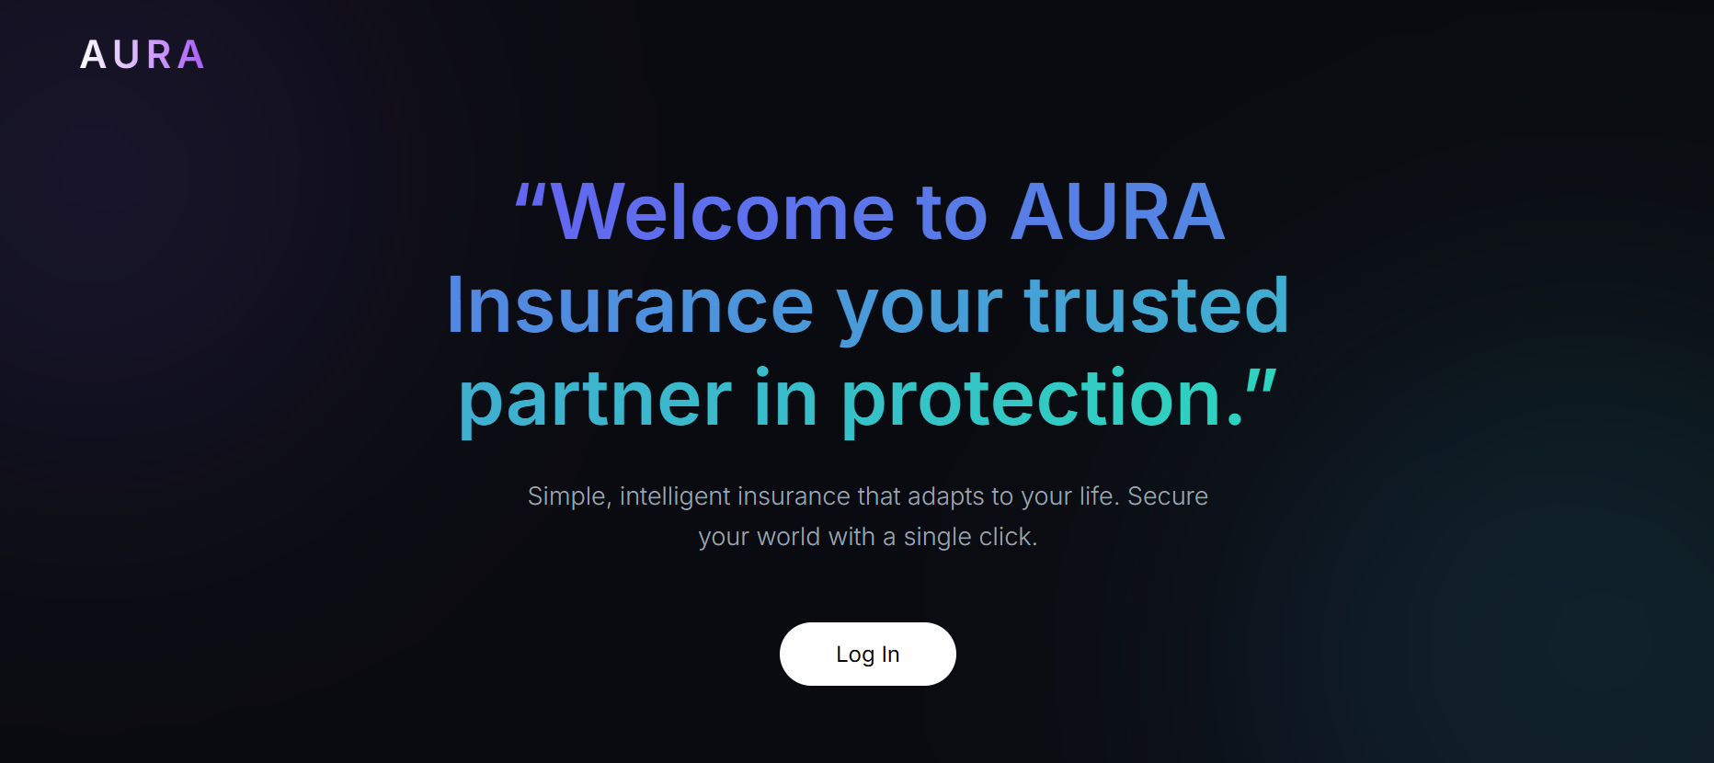
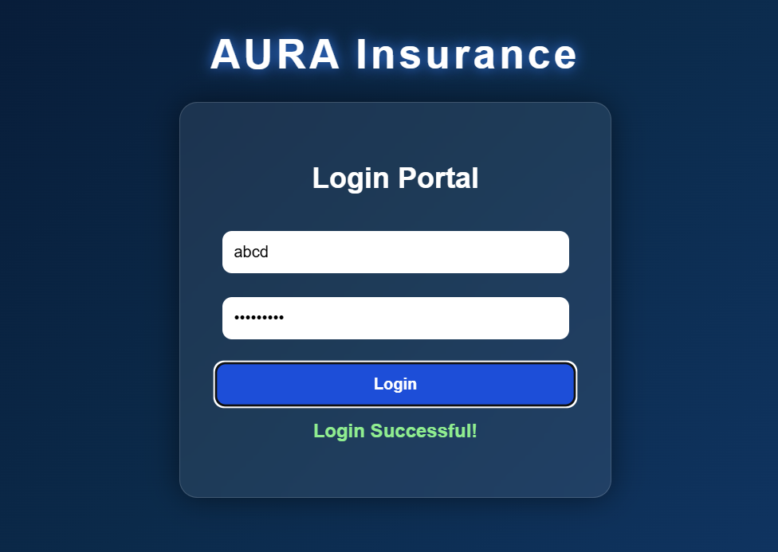
OPEN NOW:
Link to login page: https://glittering-duckanoo-9af7f5.netlify.app/

(user: abcd password: wecan@789)

Link to full video of website working:
https://drive.google.com/file/d/142V5jqfGjhCbAKOr8bxZvdmzEBpJkfNz/view?usp=sharing

PYTHON APPLICATION – SECURE LOGIN SYSTEM

Description:
This Python program is a simple console-based login system developed as part of a cybersecurity project. It demonstrates secure authentication using password hashing techniques to improve security compared to plain text password storage.

Login Credentials:
Username: sree
Password: wecan@789

Working:
- The system takes username and password as input from the user
- The password is converted into a hashed format using the SHA-256 algorithm
- The hashed input is compared with the stored hashed password
- If both username and hashed password match, login is successful
- Otherwise, access is denied

Security Features:
- Password is not stored in plain text
- SHA-256 hashing is used for secure password storage
- Prevents direct exposure of sensitive credentials

Code Explanation:
The program uses the hashlib library in Python to implement SHA-256 hashing. The stored password is first converted into a hashed format. When the user enters a password, it is also hashed and then compared with the stored hash for authentication.
CODE:
import hashlib
stored_username = "sree"
stored_password = hashlib.sha256("wecan@789".encode()).hexdigest()

username = input("Enter username: ")
password = input("Enter password: ")

hashed_input = hashlib.sha256(password.encode()).hexdigest()

if username == stored_username and hashed_input == stored_password:
print("Login Successful!")
else:
print("Invalid credentials")

IMAGES:
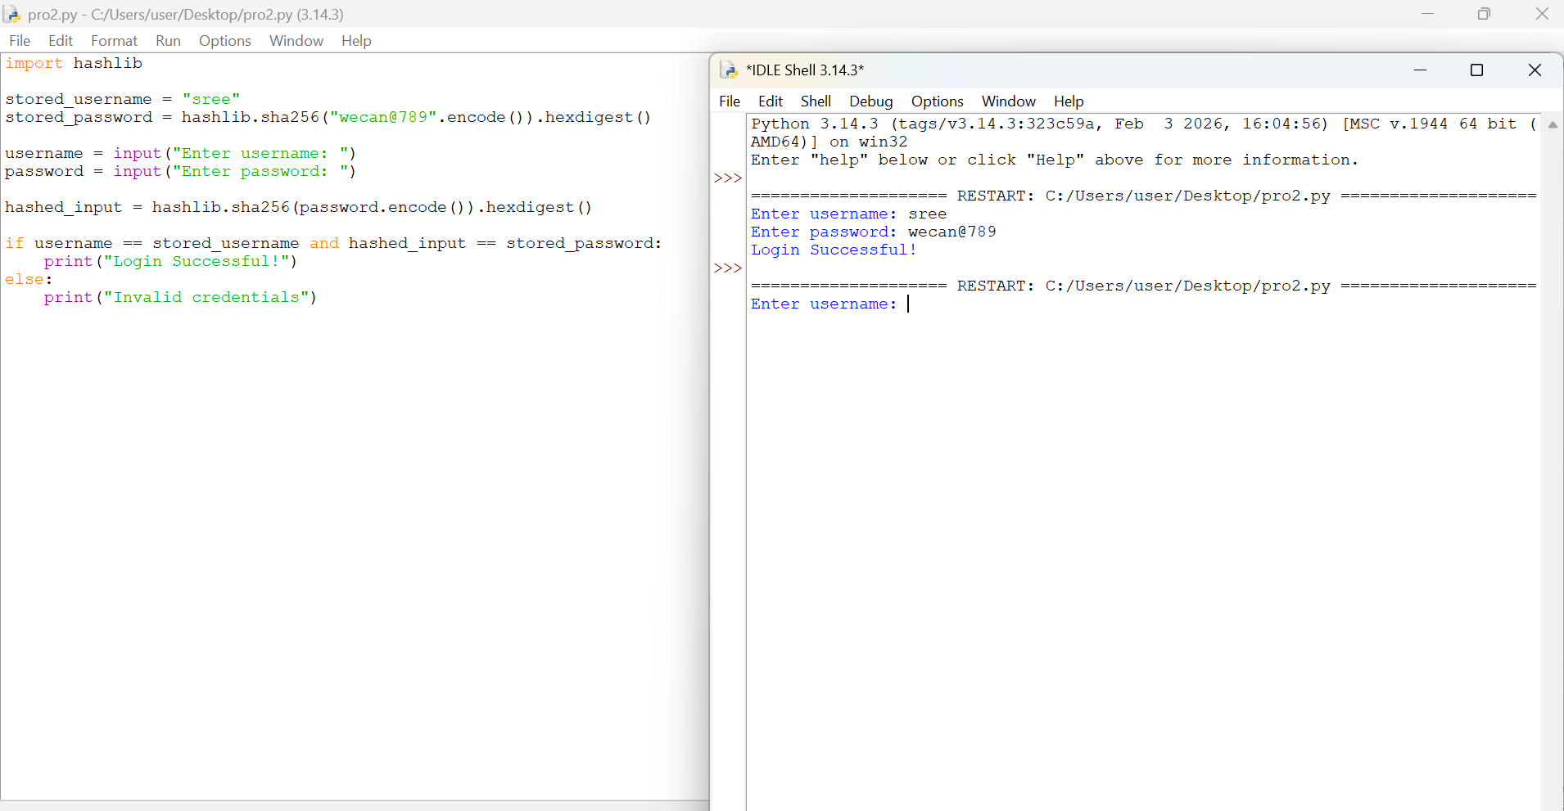
Link to OPEN pdf of used code:
https://drive.google.com/file/d/1OSgtRUcvXSI5X_O4cmkxycwURBhf2J3C/view?usp=sharing

